Chapter 7 Hypothesis Tests and Confidence Intervals in Multiple Regression

Outline
- Hypothesis tests and confidence intervals for one coefficient
- Joint hypothesis tests on multiple coefficients
- Other types of hypotheses involving multiple coefficients
- Variables of interest, control variables, and how to decide which variables to include in a regression model

7.1 Hypothesis Tests and Confidence Intervals for a Single Coefficient

Hypothesis tests and confidence intervals for a single coefficient in multiple regression follow the same logic and recipe as for the slope coefficient in a single-regressor model.
- 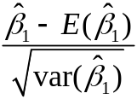 is approximately distributed N(0,1) (CLT).
- Thus hypotheses on β₁ can be tested using the usual t-statistic, and confidence intervals are constructed as {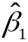 ±1.96 x SE()}.
- So too for β₂,…, β_{k}.

Example: The California class size data
(1) Testscore = 698.9 – 2.28STR
(10.4) (0.52)
(2) Testscore = 686.0 – 1.10STR – 0.650PctEL
(8.7) (0.43) (0.031)
- The coefficient on STR in (2) is the effect on TestScores of a unit change in STR, holding constant the percentage of English Learners in the district
- The coefficient on STR falls by 1.10
- The 95% confidence interval for coefficient on STR in (2) is
{–1.10 ±1.96(0.43)} = (–1.95, –0.26)
- The t-statistic testing β_{STR} = 0 is t = –1.10/0.43 = –2.54, so we reject the hypothesis at the 5% significance level
Standard errors in multiple regression in STATA

reg testscr str pctel, robust;

Regression with robust standard errors Number of obs = 420
F( 2, 417) = 223.82
Prob > F = 0.0000
R-squared = 0.4264
Root MSE = 14.464

------------------------------------------------------------------------------
| Robust
testscr | Coef. Std. Err. t P>|t| [95% Conf. Interval]
-------------+----------------------------------------------------------------
str | -1.101296 .4328472 -2.54 0.011 -1.95213 -.2504616
pctel | -.6497768 .0310318 -20.94 0.000 -.710775 -.5887786
_cons | 686.0322 8.728224 78.60 0.000 668.8754 703.189
------------------------------------------------------------------------------

Testscore = 686.0 – 1.10STR – 0.650PctEL
(8.7) (0.43) (0.031)
We use heteroskedasticity-robust standard errors – for exactly the same reason as in the case of a single regressor.

7.2 Tests of Joint Hypotheses

Let Expn = expenditures per pupil and consider the population regression model:

TestScore_{i} = β₀ + β₁STR_{i} + β₂Expn_{i} + β₃PctEL_{i} + u_{i}

The null hypothesis that “school resources don’t matter,” and the alternative that they do, corresponds to:

- A joint hypothesis specifies a value for two or more coefficients, that is, it imposes a restriction on two or more coefficients.
- In general, a joint hypothesis will involve q restrictions. In the example above, q = 2, and the two restrictions are β₁ = 0 and β₂ = 0.
- A “common sense” idea is to reject if either of the individual t-statistics exceeds 1.96 in absolute value.
- But this “one at a time” test isn’t valid: the resulting test rejects too often under the null hypothesis (more than 5%)!

Why can’t we just test the coefficients one at a time?

Because the rejection rate under the null isn’t 5%. We’ll calculate the probability of incorrectly rejecting the null using the “common sense” test based on the two individual t-statistics.

To simplify the calculation, suppose that and 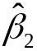 are independently distributed (this isn’t true in general – just in this example). Let t₁ and t₂ be the t-statistics:
t₁ = 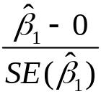 and t₂ = 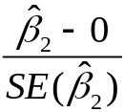
The “one at time” test is:

What is the probability that this “one at a time” test rejects H₀, when H₀ is actually true? (It should be 5%.)

Suppose t₁ and t₂ are independent (for this example).

The probability of incorrectly rejecting the null hypothesis using the “one at a time” test

The size of a test is the actual rejection rate under the null hypothesis.
- The size of the “common sense” test isn’t 5%!

- In fact, its size depends on the correlation between t₁ and t₂ (and thus on the correlation between and ).

Two Solutions:
- Use a different critical value in this procedure – not 1.96 (this is the “Bonferroni method – see SW App. 7.1) (this method is rarely used in practice however)
- Use a different test statistic designed to test both β₁ and β₂ at once: the F-statistic (this is common practice)

The F-statistic

The F-statistic tests all parts of a joint hypothesis at once.

Formula for the special case of the joint hypothesis β₁ = β_{1,0} and β₂ = β_{2,0} in a regression with two regressors:

F = 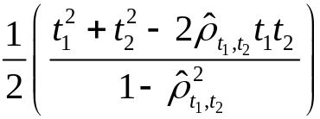

where 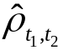 estimates the correlation between t₁ and t₂.

Reject when F is large (how large?)

- The F-statistic is large when t₁ and/or t₂ is large
- The F-statistic corrects (in just the right way) for the correlation between t₁ and t₂.
- The formula for more than two β’s is nasty unless you use matrix algebra.
- This gives the F-statistic a nice large-sample approximate distribution, which is…

Large-sample distribution of the F-statistic
Consider the special case that t₁ and t₂ are independent, so 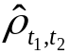 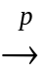 0; in large samples the formula becomes

- Under the null, t₁ and t₂ have standard normal distributions that, in this special case, are independent
- The large-sample distribution of the F-statistic is the distribution of the average of two independently distributed squared standard normal random variables.

The chi-squared distribution
The chi-squared distribution with q degrees of freedom (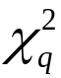) is defined to be the distribution of the sum of q independent squared standard normal random variables.

In large samples, F is distributed as 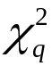/q.

Selected large-sample critical values of 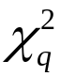/q
q 5% critical value
1 3.84 why?
2 3.00
3 2.60
4 2.37
5 2.21

Computing the p-value using the F-statistic:
p-value = tail probability of the 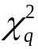/q distribution beyond the F-statistic computed.

Implementation in STATA
Use the “test” command after the regression

Example: Test the joint hypothesis that the population coefficients on STR and expenditures per pupil (expn_stu) are both zero, against the alternative that at least one of the population coefficients is nonzero.

F-test example, California class size data:

reg testscr str expn_stu pctel, r;

Regression with robust standard errors Number of obs = 420
F( 3, 416) = 147.20
Prob > F = 0.0000
R-squared = 0.4366
Root MSE = 14.353

------------------------------------------------------------------------------
| Robust
testscr | Coef. Std. Err. t P>|t| [95% Conf. Interval]
-------------+----------------------------------------------------------------
str | -.2863992 .4820728 -0.59 0.553 -1.234001 .661203
expn_stu | .0038679 .0015807 2.45 0.015 .0007607 .0069751
pctel | -.6560227 .0317844 -20.64 0.000 -.7185008 -.5935446
_cons | 649.5779 15.45834 42.02 0.000 619.1917 679.9641
------------------------------------------------------------------------------
NOTE
test str expn_stu; The test command follows the regression

( 1) str = 0.0 There are q=2 restrictions being tested
( 2) expn_stu = 0.0

F( 2, 416) = 5.43 The 5% critical value for q=2 is 3.00
Prob > F = 0.0047 Stata computes the p-value for you

More on F-statistics.
There is a simple formula for the F-statistic that holds only under homoskedasticity (so it isn’t very useful) but which nevertheless might help you understand what the F-statistic is doing.

The homoskedasticity-only F-statistic
When the errors are homoskedastic, there is a simple formula for computing the “homoskedasticity-only” F-statistic:
- Run two regressions, one under the null hypothesis (the “restricted” regression) and one under the alternative hypothesis (the “unrestricted” regression).
- Compare the fits of the regressions – the R²s – if the “unrestricted” model fits sufficiently better, reject the null

The “restricted” and “unrestricted” regressions
Example: are the coefficients on STR and Expn zero?

Unrestricted population regression (under H₁):

Restricted population regression (that is, under H₀):

- The number of restrictions under H₀ is q = 2 (why?).
- The fit will be better (R² will be higher) in the unrestricted regression
By how much must the R² increase for the coefficients on Expn and PctEL to be judged statistically significant?
Simple formula for the homoskedasticity-only F-statistic:

F = 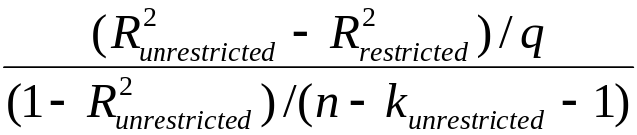
where:
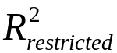= the R² for the restricted regression
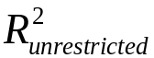 = the R² for the unrestricted regression
q = the number of restrictions under the null
k_{unrestricted} = the number of regressors in the unrestricted regression.

Example:
Restricted regression:
Testscore = 644.7 –0.671PctEL, 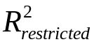 = 0.4149
- (0.032)

Unrestricted regression:
Testscore = 649.6 – 0.29STR + 3.87Expn – 0.656PctEL
(15.5) (0.48) (1.59) (0.032)
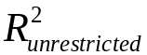 = 0.4366, k_{unrestricted} = 3, q = 2

So

Note: Heteroskedasticity-robust F = 5.43…
The homoskedasticity-only F-statistic – summary
F = 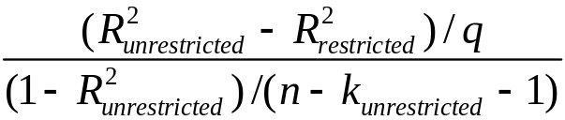

- The homoskedasticity-only F-statistic rejects when adding the two variables increased the R² by “enough” – that is, when adding the two variables improves the fit of the regression by “enough”
- If the errors are homoskedastic, then the homoskedasticity-only F-statistic has a large-sample distribution that is /q.
- But if the errors are heteroskedastic, the large-sample distribution of the homoskedasticity-only F-statistic is not /q

The F distribution
Your regression printouts might refer to the “F” distribution.

If the four multiple regression LS assumptions hold and if:
- u_{i} is homoskedastic, that is, var(u|X₁,…,X_{k}) does not depend on X’s
- u₁,…,u_{n} are normally distributed

then the homoskedasticity-only F-statistic has the
“F_{q,n-k–1}” distribution, where q = the number of restrictions and k = the number of regressors under the alternative (the unrestricted model).

- The F distribution is to the /q distribution what the t_{n–1} distribution is to the N(0,1) distribution
The F_{q,n–k–1} distribution:
- The F distribution is tabulated many places
- As n → ∞, the F_{q,n-k–1} distribution asymptotes to the 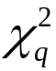/q distribution:
The F_{q,∞} and 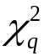/q distributions are the same.
- For q not too big and n≥100, the F_{q,n–k–1} distribution and the 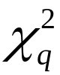/q distribution are essentially identical.
- Many regression packages (including STATA) compute p-values of F-statistics using the F distribution
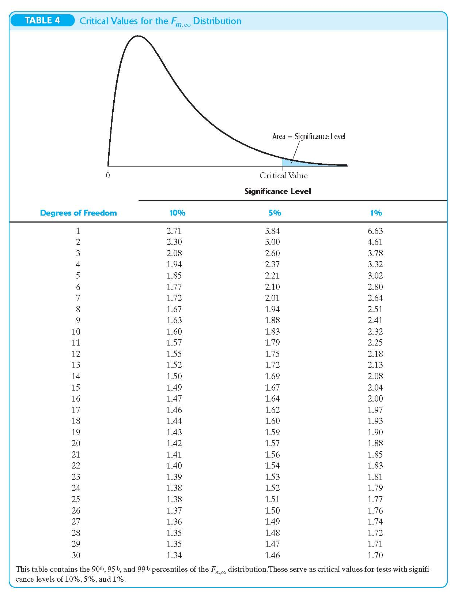
Summary: the homoskedasticity-only F-statistic and the F distribution

- These are justified only under very strong conditions – stronger than are realistic in practice.
- You should use the heteroskedasticity-robust F-statistic, with /q (that is, F_{q,∞} ) critical values.
- For n ≥ 100, the F-distribution essentially is the 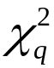/q distribution.
- For small n, sometimes researchers use the F distribution because it has larger critical values and in this sense is more conservative.

Chow Tests:
    - Returning to our wage regression, should we allow all parameters to vary by gender (e.g. run separate regressions for males and females)? What model fits the data better?
    - This is a chow test, or test of parameter constancy. We begin with the null hypothesis that the parameters for the separate wage regressions are identical: 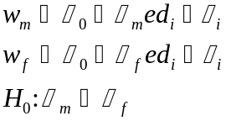. This is the unrestricted model because the parameters are allowed to take on different values for each gender.
    - We compare this to the restricted model that does not control for gender: 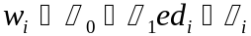
    - To test this hypothesis, we use a modified version of the F-test, using the ESS for the restricted and unrestricted models. The ESS_{R} is the same as always.
    - However, the ESS_{UR}= ESS_{F} + ESS_{M}. The degrees of freedom is the sum of the degrees of freedom for each individual regression: df(M) = (M-k); df(F) = (F-k) = M+F-2k, where M is the number of observations in the male regression; F is the number of observations in the female regression; and k is the number of independent regressors in each model including the constant term.
    - Form the F-statistic: 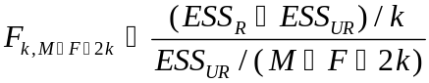. If this test statistic is larger than the critical value, we reject the null hypothesis that the parameter on education is the same for each gender.
Summary: testing joint hypotheses

- The “one at a time” approach of rejecting if either of the t-statistics exceeds 1.96 rejects more than 5% of the time under the null (the size exceeds the desired significance level)
- The heteroskedasticity-robust F-statistic is built in to STATA (“test” command); this tests all q restrictions at once.
- For n large, the F-statistic is distributed 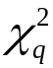/q (= F_{q,∞})
- The homoskedasticity-only F-statistic can help intuition, but isn’t valid when there is heteroskedasticity

7.3 Testing Single Restrictions on Multiple Coefficients

Y_{i} = β₀ + β₁X_{1i} + β₂X_{2i} + u_{i}, i = 1,…,n

Consider the null and alternative hypothesis,

H₀: β₁ = β₂ vs. H₁: β₁ ≠ β₂

This null imposes a single restriction (q = 1) on multiple coefficients – it is not a joint hypothesis with multiple restrictions (compare with β₁ = 0 and β₂ = 0).

Here are two methods for testing single restrictions on multiple coefficients:

- Rearrange (“transform”) the regression

Rearrange the regressors so that the restriction becomes a restriction on a single coefficient in an equivalent regression; or,

- Perform the test directly

Some software, including STATA, lets you test restrictions using multiple coefficients directly
Method 1: Rearrange (“transform”) the regression

Y_{i} = β₀ + β₁X_{1i} + β₂X_{2i} + u_{i}
H₀: β₁ = β₂ vs. H₁: β₁ ≠ β₂

- These two regressions ((a) and (b)) have the same R², the same predicted values, and the same residuals.
- The testing problem is now a simple one: test whether γ₁ = 0 in regression (b).
Method 2: Perform the test directly

Y_{i} = β₀ + β₁X_{1i} + β₂X_{2i} + u_{i}
H₀: β₁ = β₂ vs. H₁: β₁ ≠ β₂
Example:
TestScore_{i} = β₀ + β₁STR_{i} + β₂Expn_{i} + β₃PctEL_{i} + u_{i}

In STATA, to test β₁ = β₂ vs. β₁ ≠ β₂ (two-sided):

regress testscore str expn pctel, robust
test str=expn

The details of implementing this method are software-specific.

